MIS MANUAL

Table of Contents

**i. Revision History**…………………………………………………………………….…..…......2

**1.0 The FundamentalS….**..………………………………………………………..….......2

**2.0 Special Information**………............……………………………………..………….3

**3.0 Gaining Access**…..............................………………………………………..…………4

**4.0 Creating a New Job….**……………………………………………….……………...5

**5.0 STANDARDS COMPLIANCE MODULE.......**………………………………………….14

**6.0 SYSTEM ADMINISTRATION MODULE...........................................................**……….17

**i. Revision History**

|  |  |  |  |
| --- | --- | --- | --- |
| **Revision Code** | **Date** | **Revised Page #** | **Revision Description** |
| **0** | **2012-09-22** | **All** | **Document was created** |
| **1** | **2013-12-31** | **All** | **Document was updated** |
| **2** | **2015-09-04** | **All** | **Document was updated** |

**1.0 The Fundamentals**

**1.1 The System**

The Job Management and Tracking System (JMTS) is a web based application intended to be used as the central system that facilitates the processes of recording, editing, viewing, reporting and tracking requisite data for any job undertaken by the Bureau of Standards Jamaica (BSJ) and any of its agents. The system is intended to be used by authorized users only. An authorized user shall be given predefined privileges. The intent behind the user privileges component of the JMTS is to ensure that authorized users can only execute predefined types of queries or tasks that are in accordance with the guidance of relevant standard operational or quality system procedures.

Currently, The JMTS web application works best when it is accessed via a Google Chrome Browser (or browsers, such as Chromium and Rockmelt, with a Google Chrome backend coding). Other cutting edge browsers such as Mozilla Firefox and Safari will also work reasonably well with the JMTS. Internet Explorer is not a recommended browser to use when accessing the JMTS. This browser may negatively impact on the intended user experience with the JMTS in ways such as faulty Graphical User Interface (GUI) display, slow functionality and so on.

**1.2 The Manual**

It must be noted that this JMTS instructions manual will be constantly revised to facilitate the repercussions of constant software development. As such, each time this manual is updated to capture germane modifications, the release code is adjusted and reflected accordingly throughout the document.

**2.0 Special Information**

**2.1 Preamble**

This chapter of the JMTS Instruction Manual discloses descriptive information regarding special terms, names and words used within this document. Wherever any of these terms, names or words appear within this document, the fonts are formatted in both bold and italics. These terms, names and words are deemed as ‘special’, simply because an understanding of this ‘special information’ may be necessary for one to fully understand and or appreciate the content of this document.

**2.2 Special Names, Terms and Words**

**2.2.1 Authorised user**is the term used to describe any individual who is permitted to log into the JMTS web application with a username and password that is specifically assigned to the individual by the BSJ’s MIS Department. Any individual who becomes a former agent of the BSJ shall not be given privilege to log into the JMTS for any reason.

**2.2.2 Earning Job**is the term used to refer to any ***Job***that directly falls under the job description of the BSJ agent(s) responsible for the job and must involve a signed BSJ ‘job contract’ or ‘technical request’ form; or a letter regarding a customer complaint.

**2.2.3 Imperative field**is the term used to refer to any GUI field, in the JMTS, which must be filled out with data and should never be left blank.

**2.2.4 JMTS Beta Phase**is the stage in which the JMTS, while undergoing constant development, is being utilised and tested by a selected subset of the intended full group of ***authorised users***. During this phase, sections of the JMTS such as, system functionalities, user privileges, GUIs and or source coding will be altered periodically. Direct and indirect feedback from the selected few ***authorised users*** are also facilitated in this development process, in a timely manner, once the feedback is relevant or reasonable.

***2.2.5 Job*** is the word used to refer to any official task that any BSJ agent undertakes.

**2.2.6 Job entry**is the term used to refer to a combination of datathat is saved in the JMTS and represent only one ***job***. Each ***job entry*** is uniquely identified by a specially generated code called a ‘job number’. However, the JMTS also makes it possible for an ***authorised user*** to develop whatever ‘job number’ he/she wishes

**2.2.7 Non-earning Job**is the term used to refer to any ***Job*** that was done within a specific financial month but involves neither an appropriate letter regarding a customer complaint, a BSJ ‘job contract’ nor ‘technical request’ form. Currently, a non-earning job is determined by its subcategory under the “Classification” GUI in the “Job Detail” form (e.g. ‘Meeting’).

**2.2.8 Release code**is the code used to indicate a specific release of the JMTS Instructions Manual. The code is written in the form ‘rev-#’, where ‘#’ represents the number of times that the document has been revised.

**2.2.9 Task entry**is the term used to refer to data entered in the JMTS, under its ‘Job Sample’ section, for task(s) involved in a ***non-earning job***.

**2.2.10 Sample entry**is the term used to refer to data entered in the JMTS, under its ‘Job Sample’ section, for each sample of product(s) involved in an ***earning job***.

**3.0 Gaining Access**

**3.1 Preamble**

This chapter of the JMTS Instruction Manual discloses step by step information on how an ***authorised user*** can access the JMTS.

**3.2 Installing Preferred Browser**

If the ***authorised user* does** not have Google Chrome, the preferred browser, installed on the system, then the following steps can be taken:

1. Use any browser already installed to go to <https://www.google.com/chrome/> then download and install the Goole Chrome browser
2. While installing the browser, if a window pops up requesting administrator account information, close that window without attempting to enter such information.

However please note the following:

1. If the user does not intend to install this browser on his/her own, assistance from the BSJ’s MIS Department may be sought.
2. Each time a user logs into his/her BSJ account on a machine that he/she has never used to install Google Chrome browser before, that user will have to install Google Chrome from his/her account on that particular machine.

**3.3 Locating and logging into the JMTS Web Application**

An ***authorised user***, on the BSJ’s local network, can locate and log into the JMTS by doing the following:

1. Open/run the preferred browser then type the JMTS URL, [http://boshrmapp:8080/jmts](https://boshrmapp:8080/jmts), in the address field at the top of the browser and click ‘enter key’.
2. When the JMTS web application is located, the correct username and password must be entered in the respective fields.
3. To enter the system at this point, one may press the ‘enter’ key or select the ‘Login’ button.

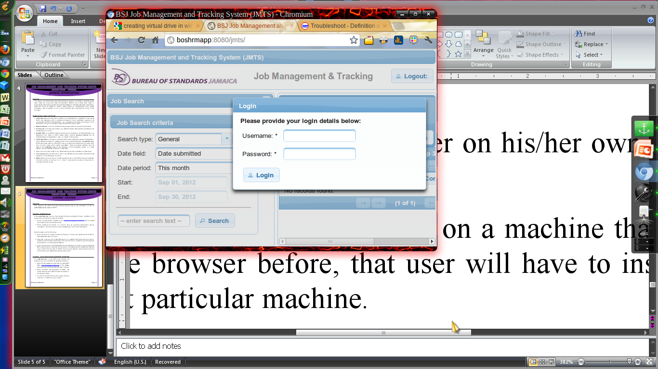

**4.0 Creating a New Job**

**4.1 Preamble**

This chapter of the JMTS Instruction Manual discloses step by step information on how an ***authorised user*** can create a new ***earning job*** or a new ***non-earning job*** after logging into the JMTS.

**4.2 Creating a New Earning Job**

Currently, only some ***authorised users*** (i.e. Customer Service Representatives and some members of the Inspectorate Division) are allowed to enter a new ***earning job*** in the JMTS. With that said, if the ***authorised user*** has the user privilege to make a ***job entry*** for an ***earning job***, the following steps can be taken to do so:

1. Click the ‘new’ button.
2. When the ‘Job Detail’ GUI pops up, each ***imperative field***, in the ‘General’ section of the interface, should be appropriately filled out.
3. If the ***job*** includes any sample(s), a ***sample entry*** should be made via the ‘Job Samples’ section of the interface by doing the following:
   1. Click the ‘Add sample(s)’ button
   2. When the ‘Job Sample’ GUI pops up, fill out the relevant fields under both the ‘General’ and ‘Tracking’ tabs.
   3. Click ‘Ok’ button to complete the ***sample entry***.
4. Click the ‘Service’ button
5. When the ‘Service’ GUI pops up, all the relevant tick boxes and or fields should be appropriately filled out and or ticked then the ‘Close’ button should be clicked to return to the ‘Job Detail’ GUI.
6. Upon returning to the ‘Job Detail’ GUI, click the ‘Job Costing’ button.
7. When the ‘Job Costing’ GUI pops up, all the relevant fields should be appropriately filled out then the ‘Close’ button should be clicked to return to the ‘Job Detail’ GUI.
8. Upon returning to the ‘Job Detail’ GUI, click ‘Save’ button then Click ‘Close’ button to complete ***job entry***.

However, please note that it is also recommended that the ‘Save’ button be clicked as much as is reasonable throughout the entire data entry process before the ***job entry*** is completed. Also, ensure that the characters inputted in each field sums up to about 100 characters at most.

**4.3 Creating a New Non-earning Job**

An ***authorised user*** maymake a ***job entry*** for a new ***non-earning job*** by using the following steps:

1. Click the ‘new’ button.
2. When the ‘Job Detail’ GUI pops up, each ***imperative field***, in the ‘General’ section of the interface, should be appropriately filled out. The following must be noted:
   1. Bureau of Standards, Jamaica (BSJ) must be entered in the field for client. This can be achieved by entering the first few letters of the client name such as “bur” in the client field then selecting the correct option in the drop down list that would have appeared thereafter. This feature is referred to as “Auto completion”.
   2. No data should be added to the field labelled ‘subcontracted dept.’.
3. Each task undertaken by the BSJ Agent for his/her ***non-earning job***, should be entered into the JMTS as follows:
   1. Click the ‘Add sample(s)’ button.
   2. When the ‘Sample Detail’ GUI pops up, briefly describe your task(s), including the time spent on them, in the ***imperative field*** labelled ‘Product(s)’ (e.g. “QMS Meeting [2hrs]” or “Sourcing lab items [3hrs] & Filing documents [5hrs]”).
   3. Click the ‘Ok’ button to complete the ***task entry***.
   4. Repeat a) to d) if more ***task entries*** are required.
4. Click the ‘Classification’ button
5. When the ‘Classification’ GUI pops up, the ‘subcategory’ drop down menu field should be used to select the correct option that classifies the ***task entry(ies)*** involved in the specific ***non-earning job*** then the ‘Close’ button should be clicked to return to the ‘Job Detail’ GUI.
6. Upon returning to the ‘Job Detail’ GUI, click the ‘Job Costing’ button.
7. When the ‘Job Costing’ GUI pops up, use the field labelled ‘Final cost ($)’, under the ‘Invoicing and Payment’ section, to enter the total monetary figure representing all task(s) undertaken in that ***non-earning job***. Thereafter, the ‘Close’ button should be clicked to return to the ‘Job Detail’ GUI.
8. Upon returning to the ‘Job Detail’ GUI, click the ‘Job Status’ button. When the ‘Job Status and Tracking’ GUI pops up, click the tic box beside the ‘Job completed by’ label. Thereafter, enter the last day of the financial month that applies to the ***non-earning job*** (e.g. If the financial month for the ***non-earning job***is Aug 26 to Sep 25 enter ‘Sep 25, 2012’). Click the ‘Close’ button.
9. Upon returning to the ‘Job Detail’ GUI, click ‘Save’ button then Click ‘Close’ button to complete ***job entry***.

However, please note that it is also recommended that the ‘Save’ button be clicked as much as is reasonable throughout the entire data entry process before the ***job entry*** is completed. Also, ensure that the characters inputted in each field sums up to about 100 characters at most; and all ***task entry(ies)***, should be correctly linked to the classification of the ***job entry***.

**4.4 Illustrations** 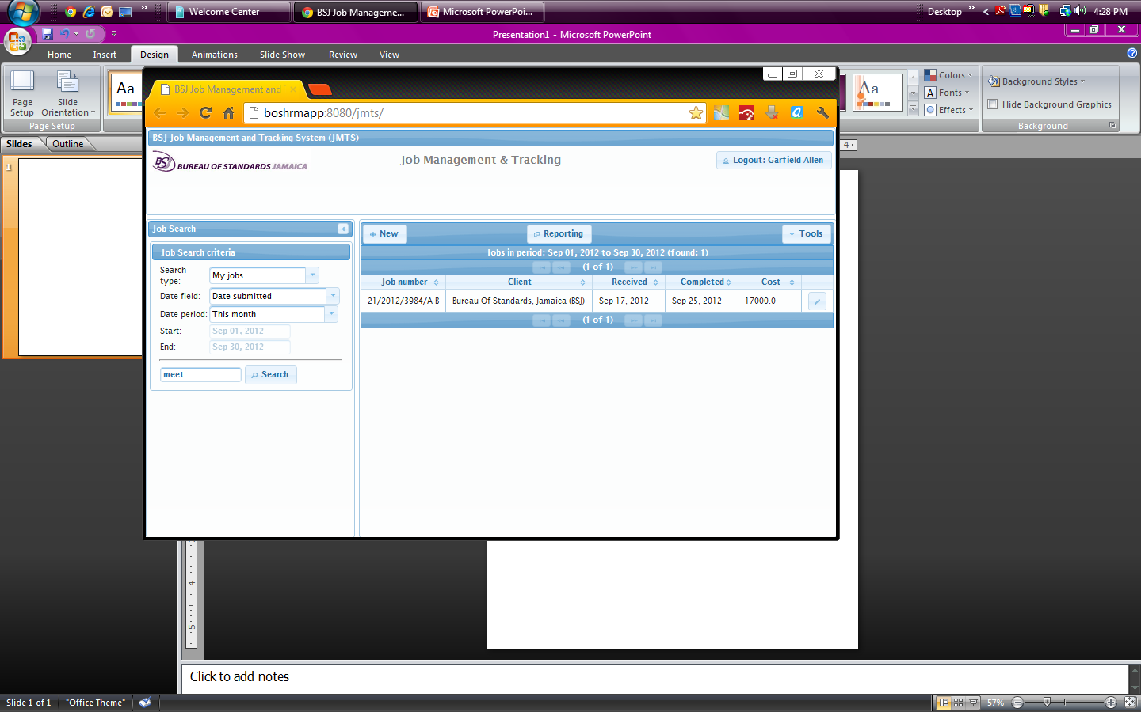

Click to create new job

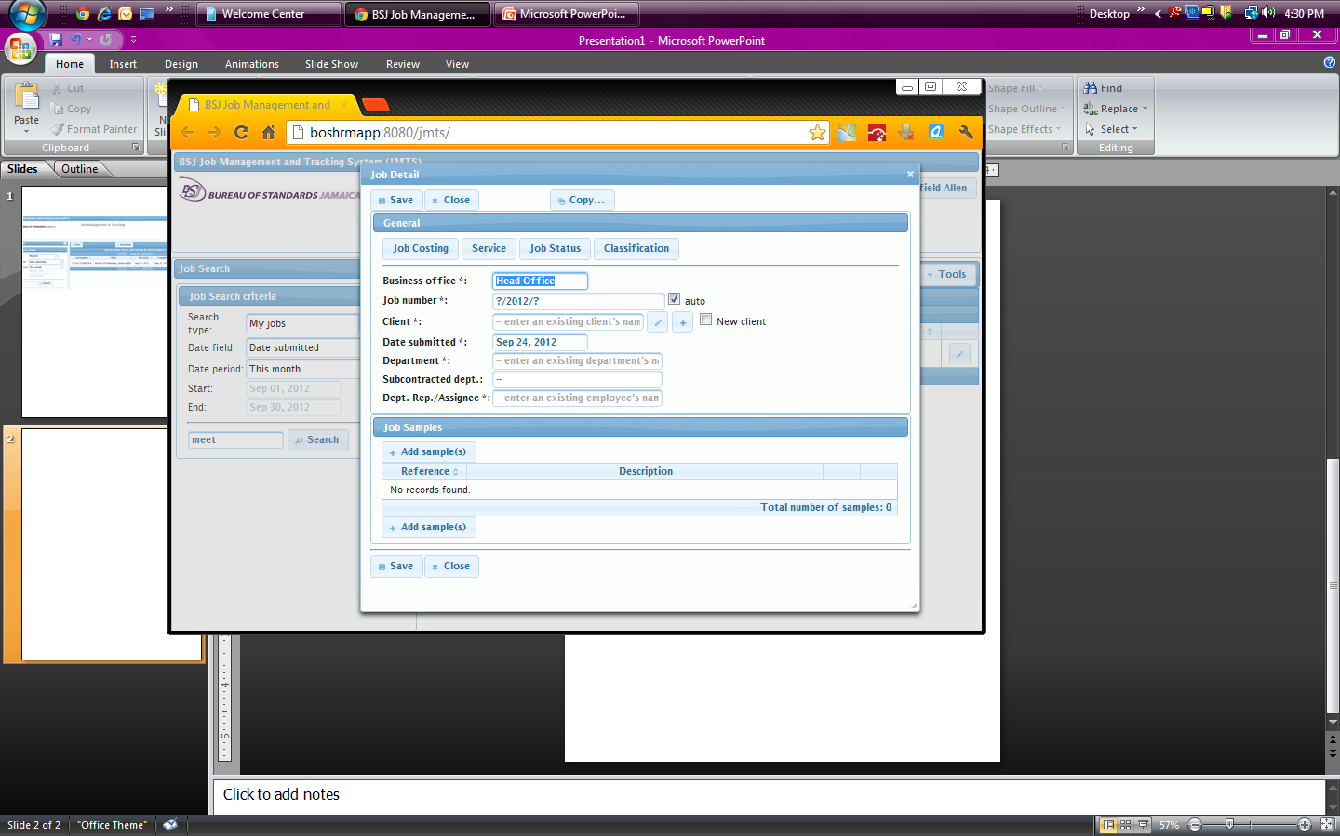

**The default Job Detail GUI**

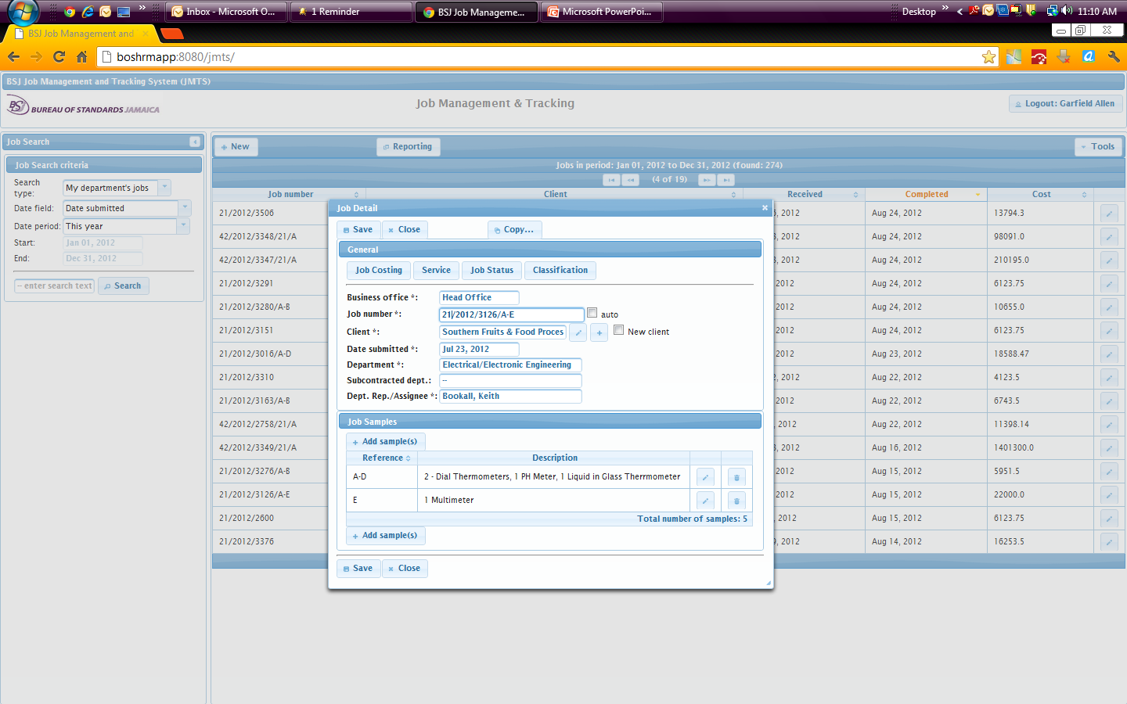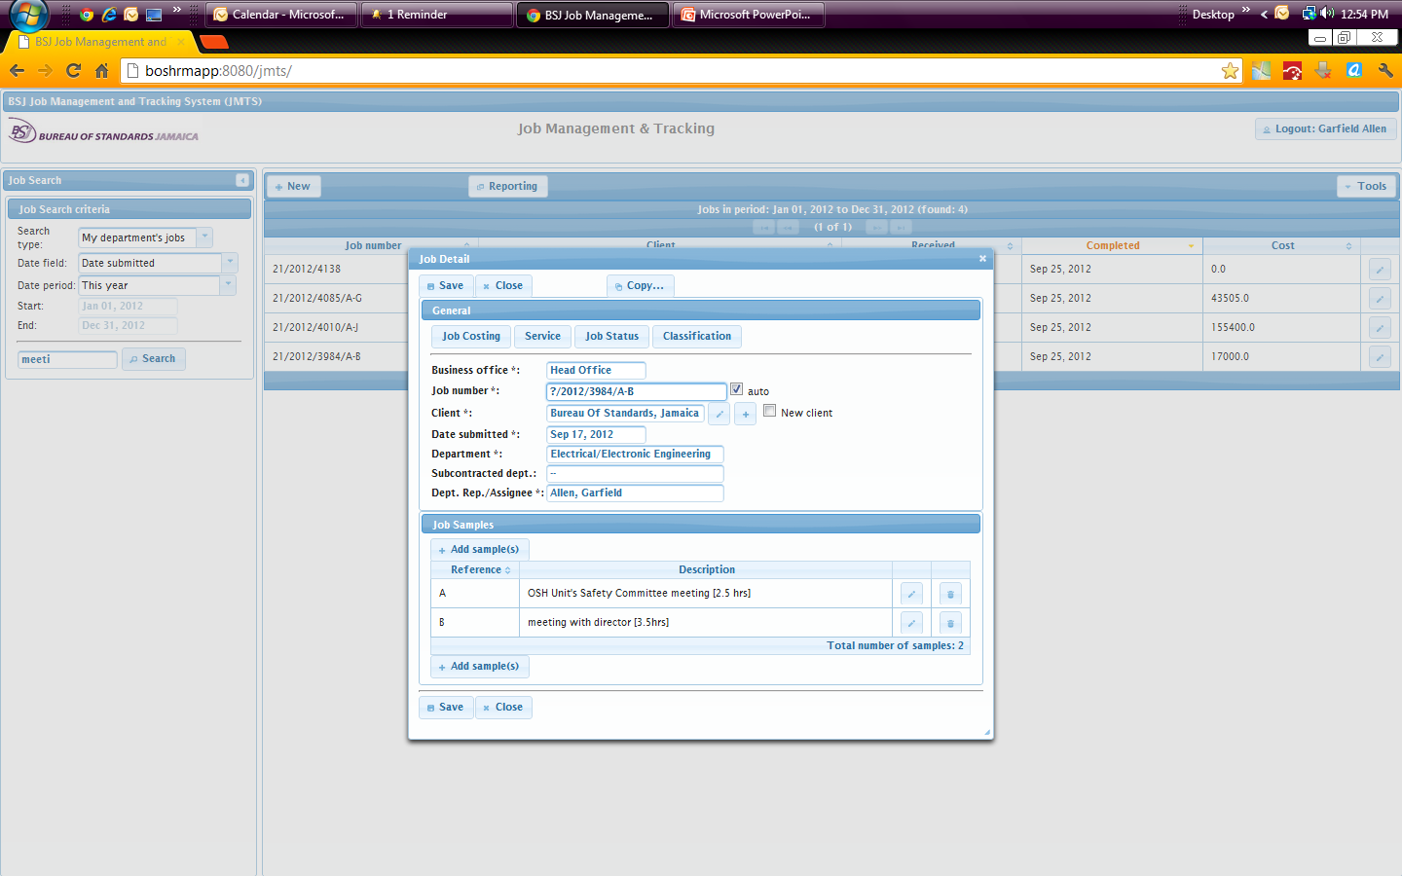

Example for earning jobs

Example for non-earning jobs

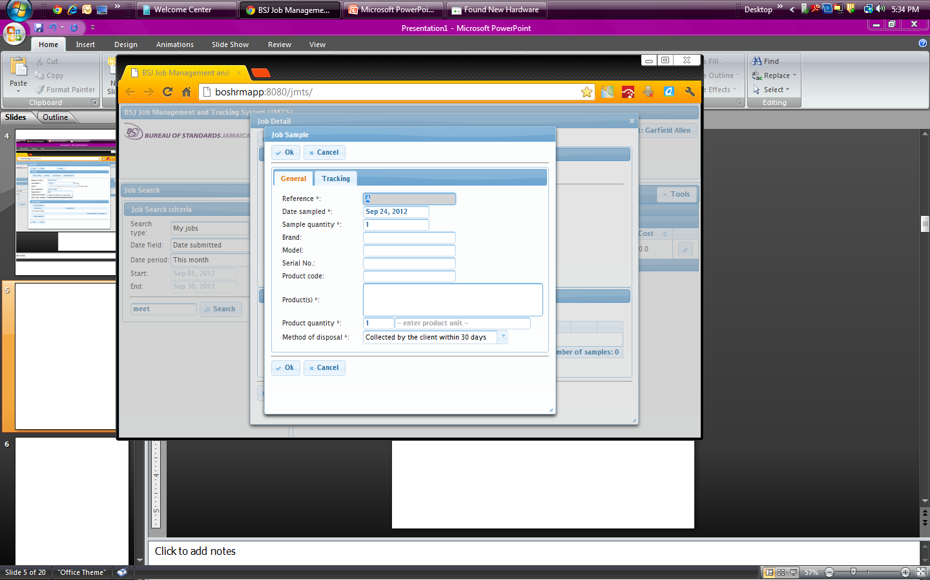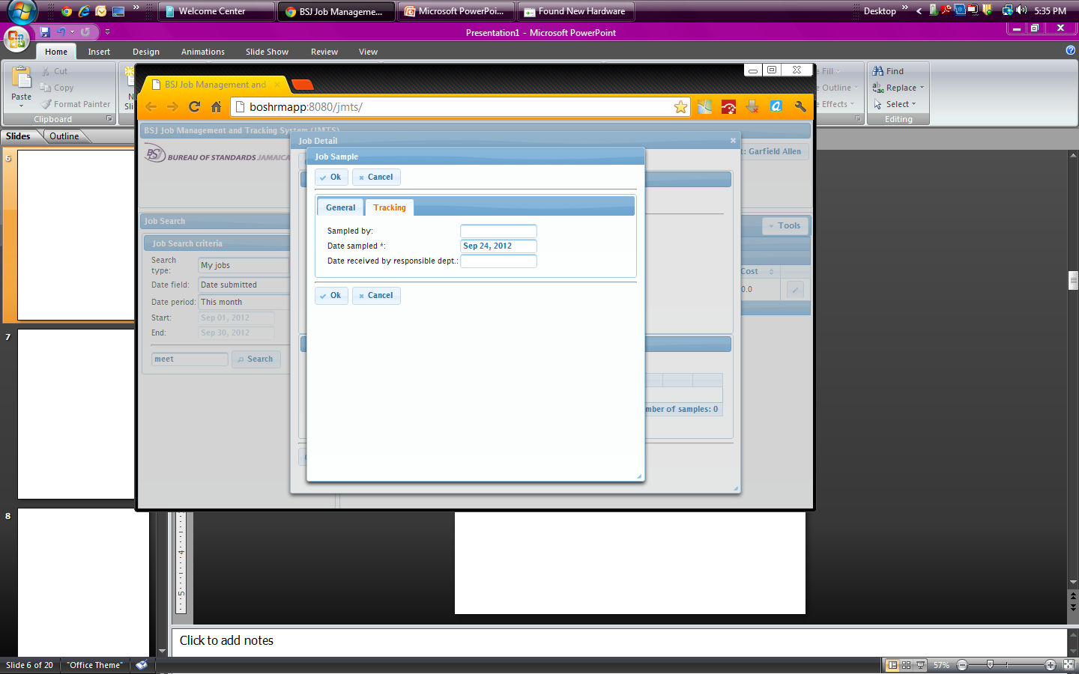

**The default Job Sample GUI**

When the general tab is selected

When the tracking tab is selected

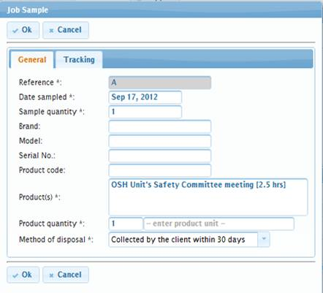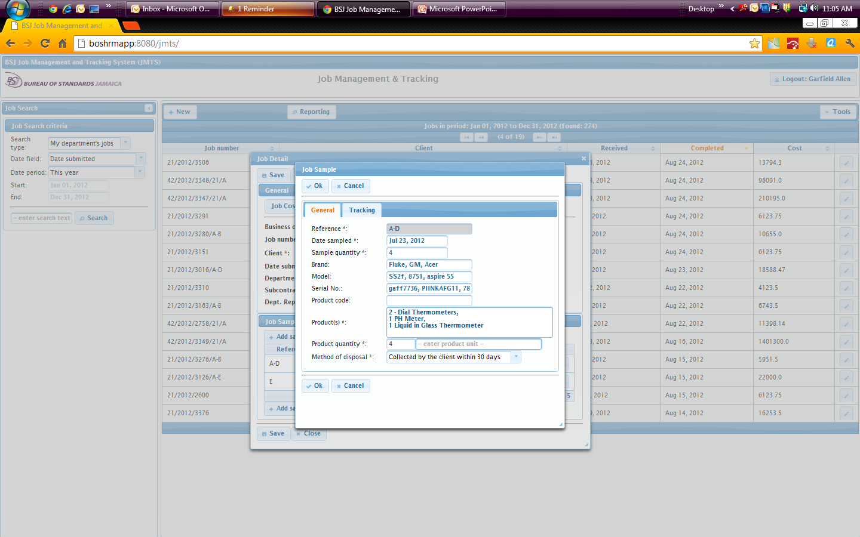

Example for earning jobs

Example for non-earning jobs

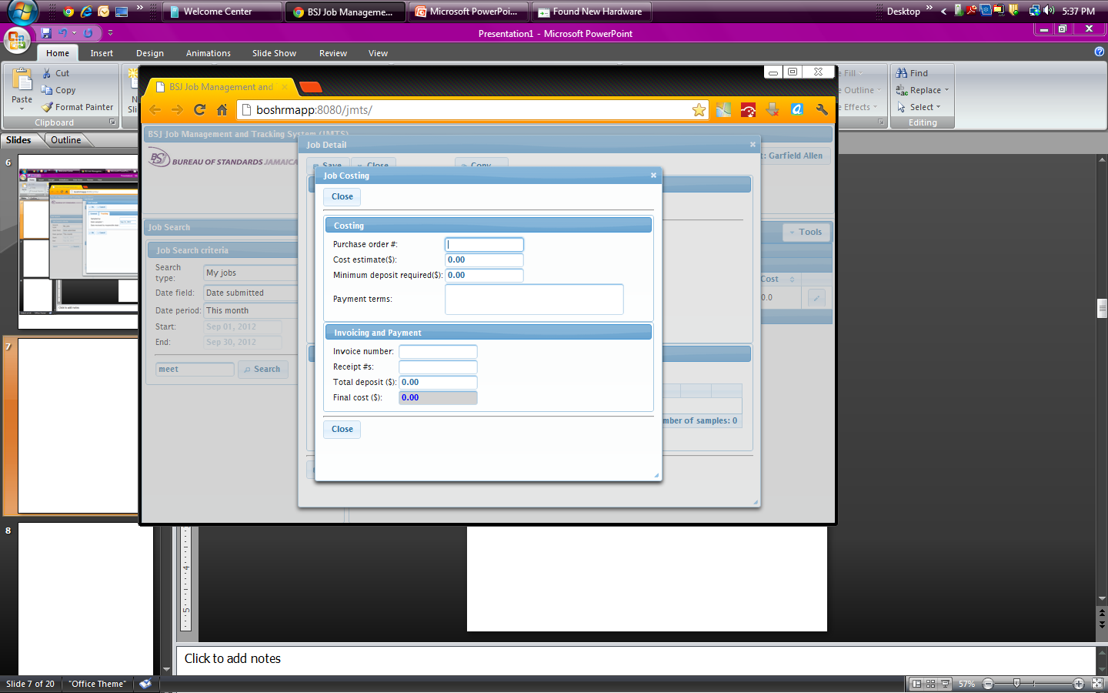

**The default Job Costing GUI**

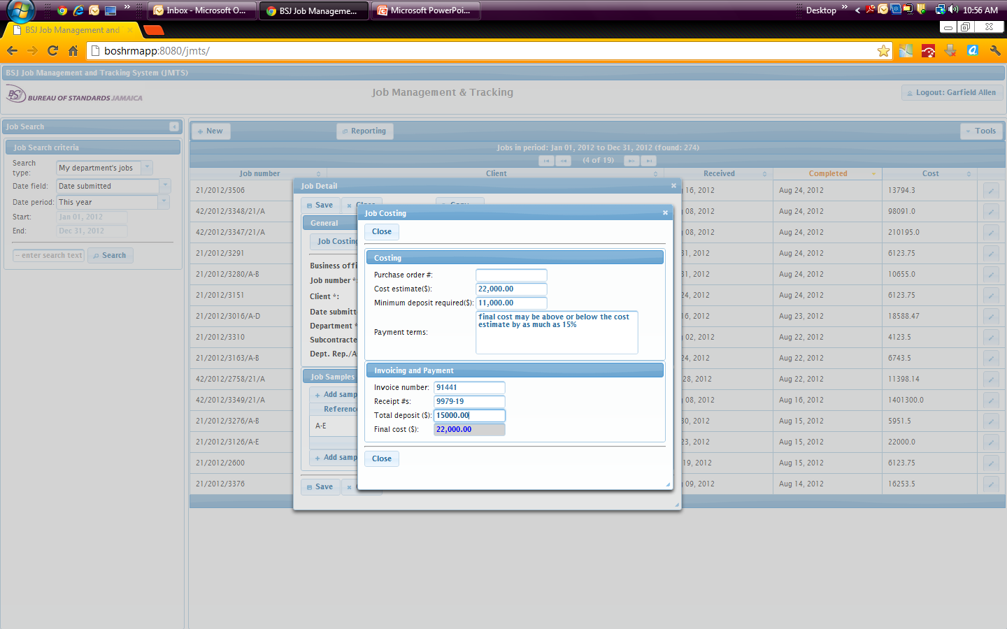

**The default Service GUI**

Example for earning jobs

Example for earning jobs

Example for non-earning jobs

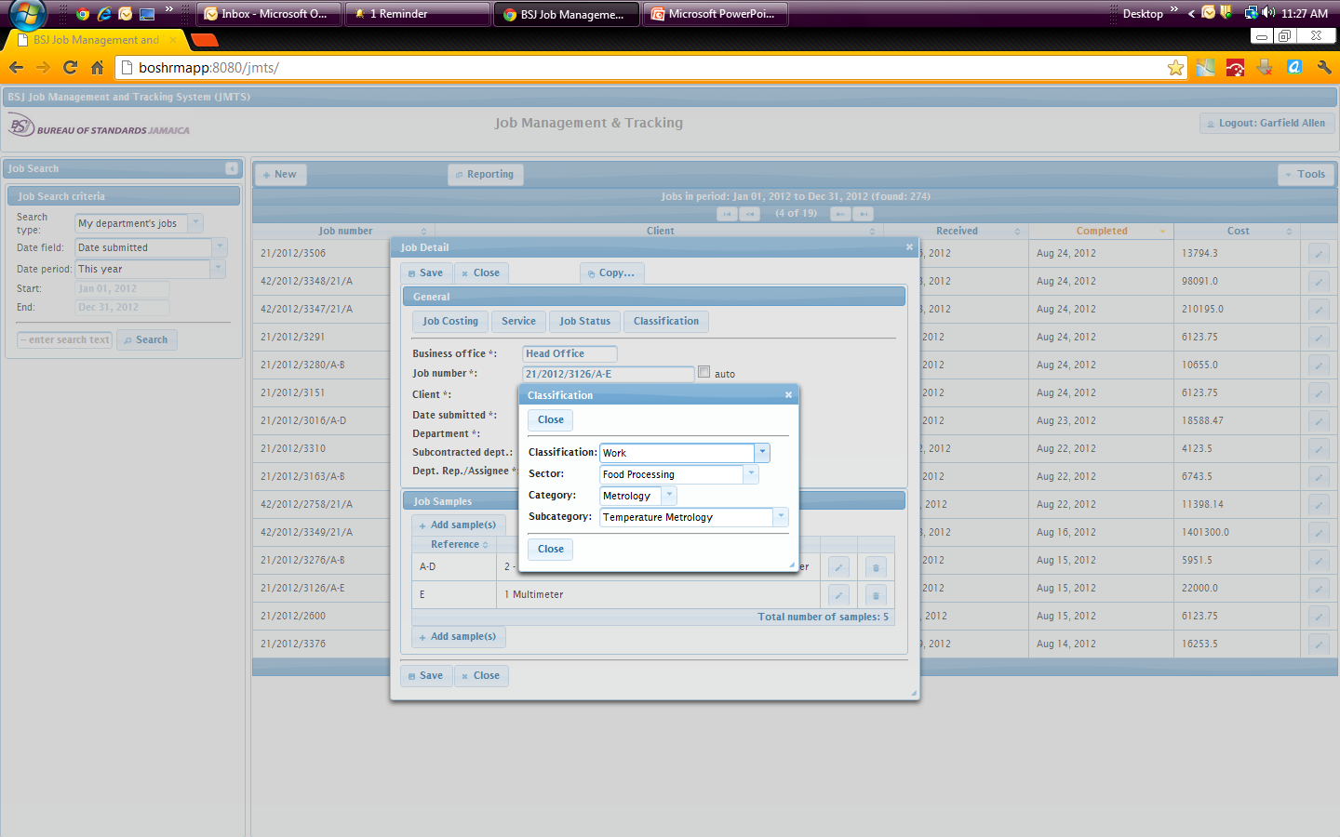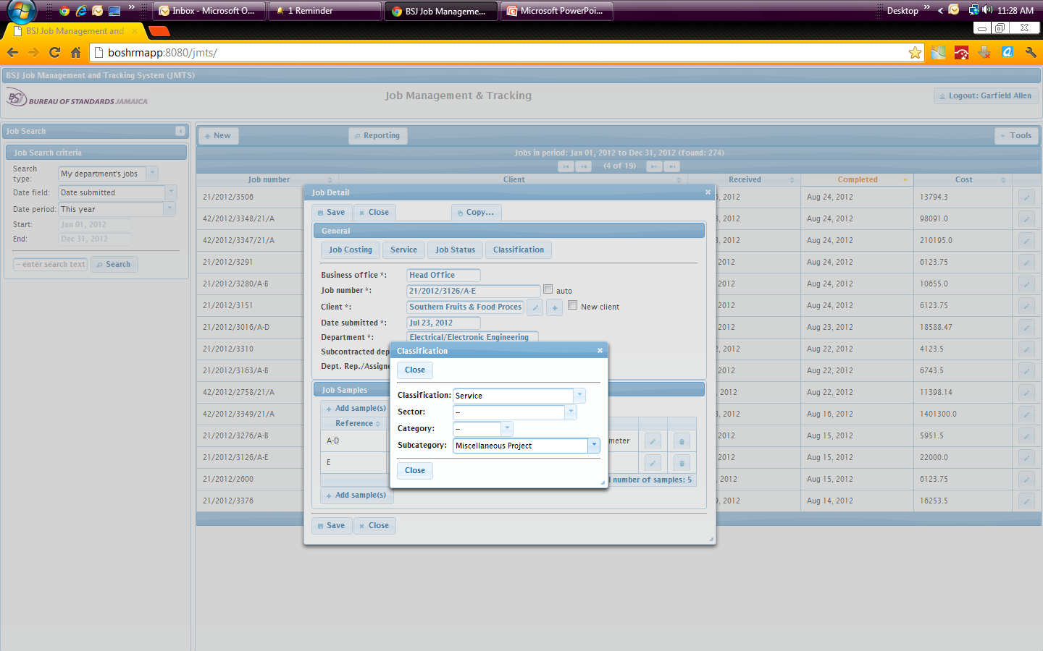

**The default Classification GUI**

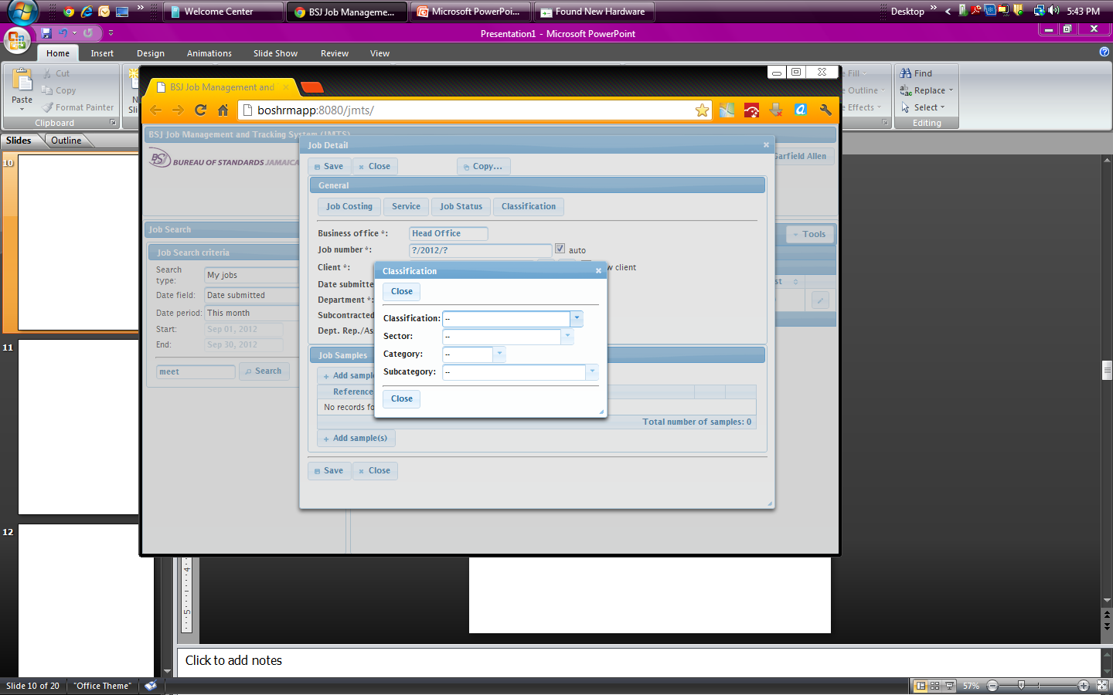

Example for earning jobs

Example for non-earning jobs

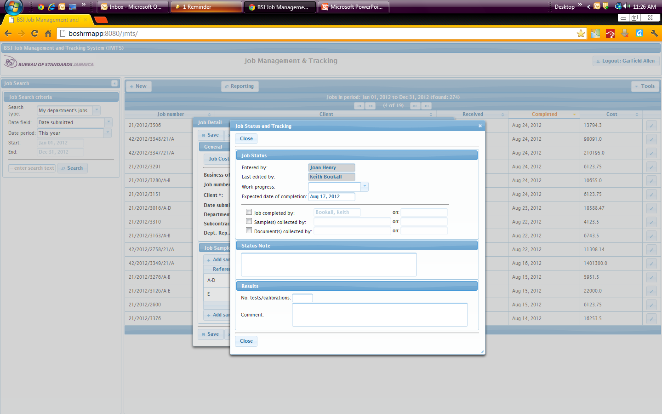

**The default Job Status and Tracking GUI**

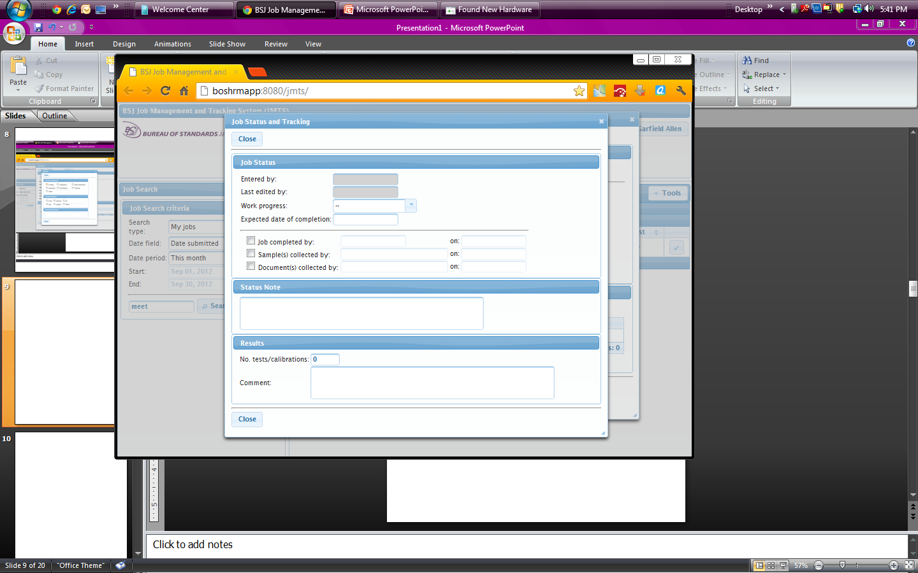

Example of the inputs that are relevant when creating an earning job

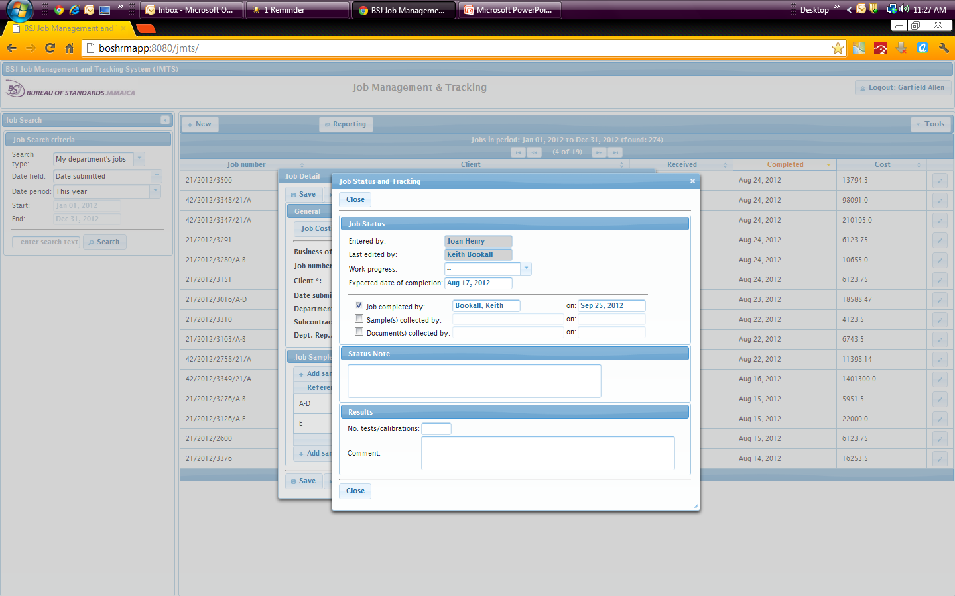

Must be blank

**The default Service GUI**

Example for earning jobs

Example of the inputs that are relevant when creating a non-earning job

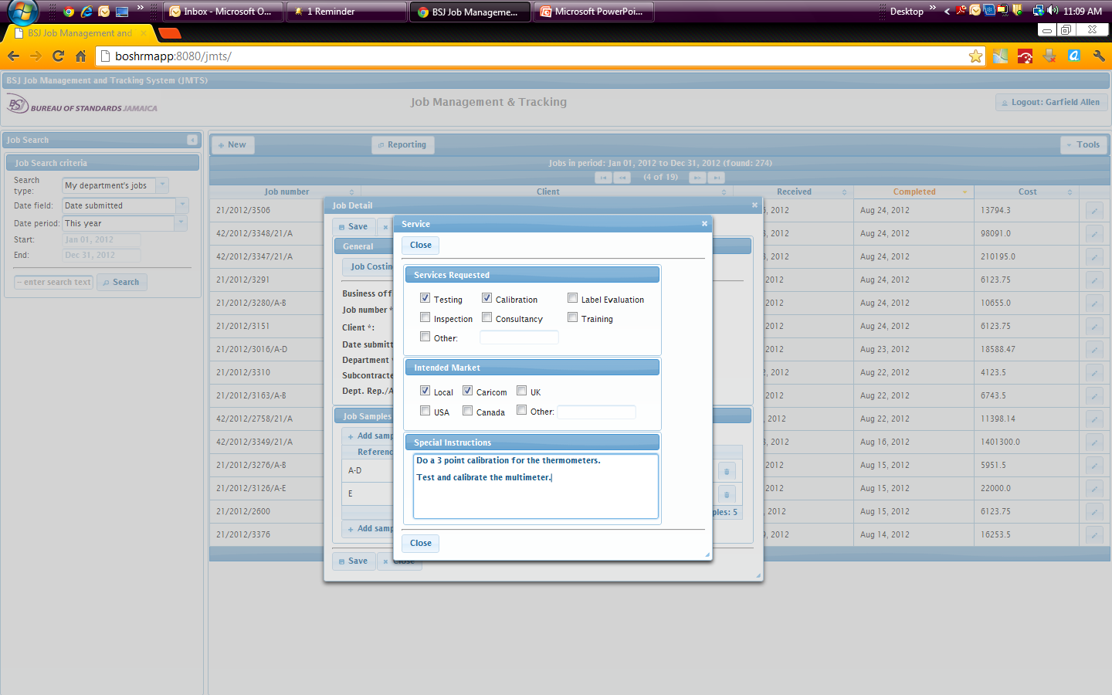

Service GUI is not used at all when creating a non-earning job

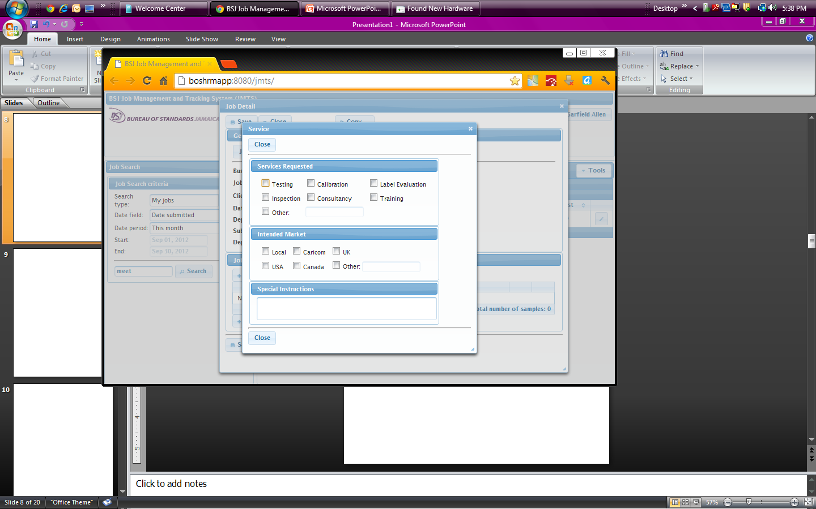

**5.0 Standards Compliance Module**

The Standards Compliance Module currently provides the facility for recording compliance surveys and product inspections. The module is activated as illustrated below:

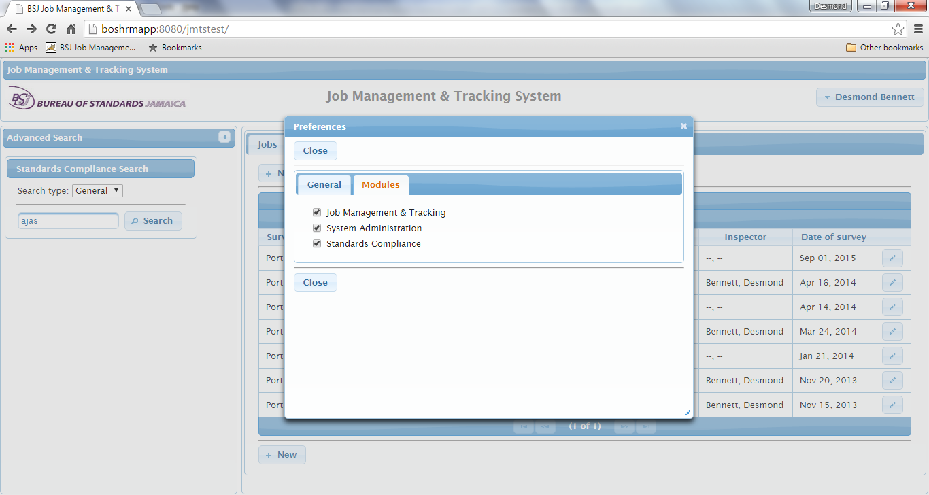

**The Standards Compliance Module is activated here**

A new tab named ‘Standards Compliance’ will appear in the GUI after the module is activated.

A new survey can be created by clicking the ‘New’ button as illustrated below:

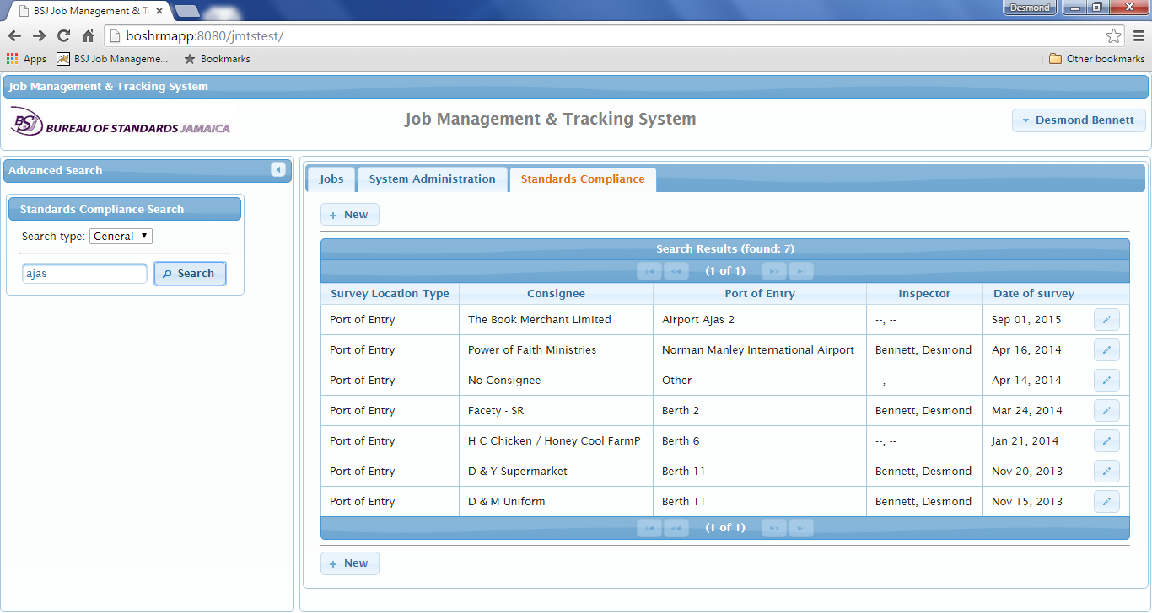

**New surveys can be created by clicking the ‘New’ button**

**5.2 The Pipeline**

Online Job Costing

Viewing Alerts  
  
System modification

Job Alerts

A form will appear that will allow the entry of compliance survey data.

The Compliance Survey form illustrated below facilitates the entry of survey data categorised by tabs.

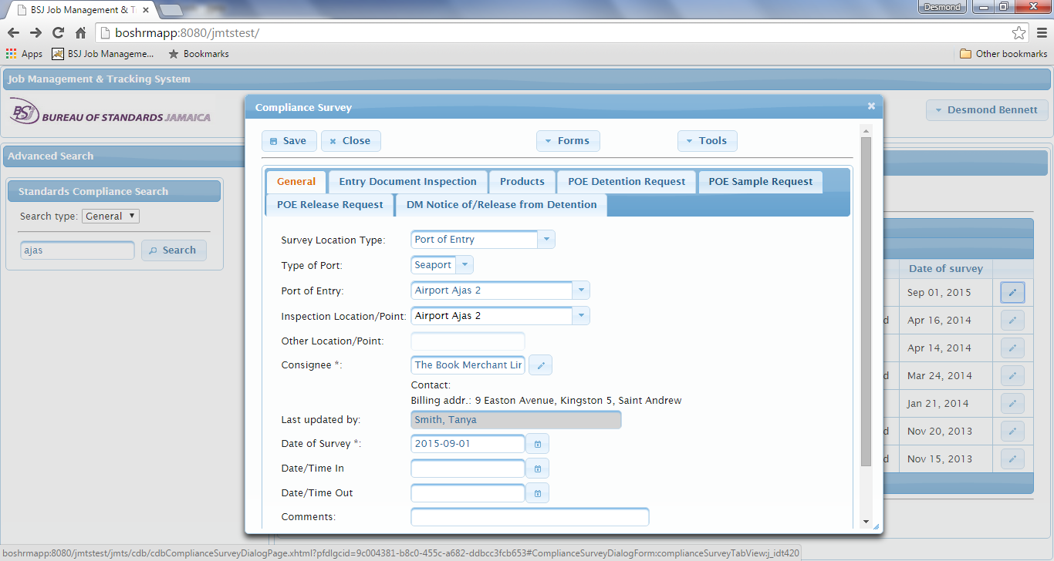

The available tabs for entering survey data are ‘General’, ‘Entry Document Inspection’, “Products’, ‘POE Detention Request’ (Port of Entry Detention Request), ‘POE Sample Request’ (Port of Entry Sample Request, ‘POE Release Request’ (Port of Entry Release Request), ‘DM Notice of/ Release from Detention’ (Domestic Market Notice of/Release from Detention.

**7.0 System Administration Module**

The Systems Administration module facilitates configuration of the system. This module is activated via the preferences dialog as illustrated below:



**The System Administration Module is activated here**

After activating the ‘System Administration’ module, a tab called ‘System Administration will appear in the GUI. Only persons who have System Administrator privileges can activate this module.

The Systems Administration module facilitates configuration of the system with respect to (1) user privileges (2) employee and department details (3) Data lists such as job classifications and sectors (4) system configuration such as Microsoft Active Directory domain and URLs. The GUI for System Administration GUI is illustrated below:

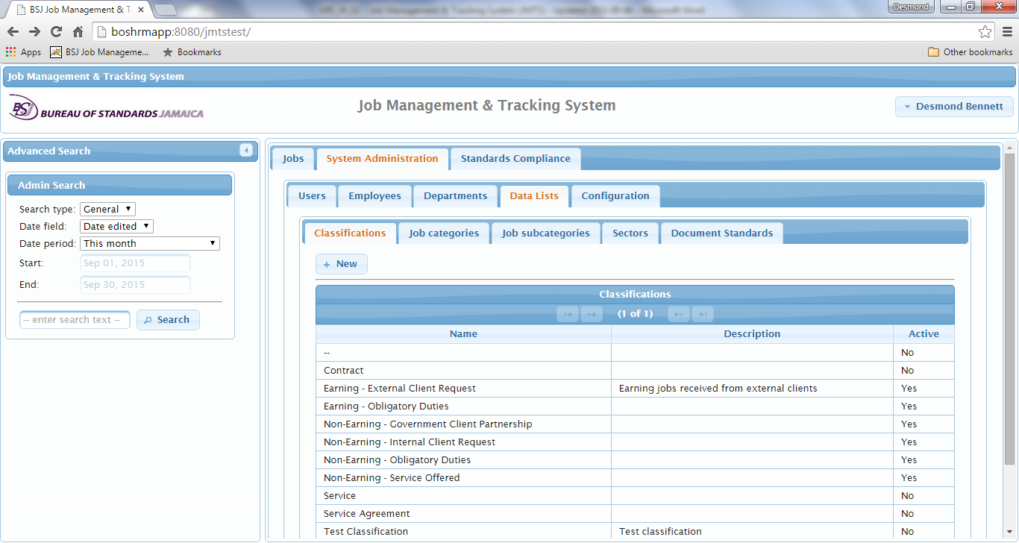

A sample screen for configuring a user’s privileges is illustrated below:

